STUDY OF MECHANICAL PERFORMANCE OF HYBRID WOVEN FABRICS AS POTENTIAL REINFORCEMENT IN COMPOSITES
Hassan Iftekhar¹^{(*)}, Zulfiqar Ali², M. Shahid Nazir³, S. Talha Hamdani⁴, Yasir Nawab⁵
¹, ⁴, ⁵ School of Engineering and Technology, National Textile University, Faisalabad, Pakistan
², ³ Department of Chemical Engineering, COMSATS University, Lahore, Pakistan
(*) Email: hasan@ntu.edu.pk
ABSTRACT
This work compares the porosity, puncture, tensile and stiffness properties of two novel hybrid woven fabrics with two basic woven fabrics (matt and 6 ends Satin)...
INTRODUCTION
The fabric can be of different types based on design and construction parameters...
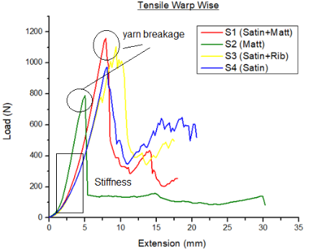
Fig. 1 Load extension curves of a) Puncture test b) Tensile test (warp wise)

RESULTS AND CONCLUSIONS
The results showed a significant effect of weave structure on the mechanical properties of developed fabrics...
REFERENCES
- Example reference.
- Another reference.
- Another reference.

